CSIT314 Software Development Methodologies - Group Project

Sprint 3 - US22: Update current IDP
Interior Design Platform - Interior Designer
Open "US22 Update current IDP.drawio" to edit all diagrams and wireframes. PNG exports are in the "diagrams" folder. The wireframes follow the existing templates and shared stylesheet.

Assumptions
- US22 updates an existing current interior design project (IDP). The designer opens its US21 preview, selects Update current IDP, edits the prefilled details and saves to see the updated preview.
- Access reuses US13: the account and profile must be Active and have both "Manage company profile" and "Manage own IDPs" permissions. Every form load and submission rechecks access.
- B-C-E is retained: UpdateCurrentIDPPage calls UpdateCurrentIDPController, which uses IDP and IDPCategory entities and the existing US13 access controller.
- Only the session owner's Active Current IDP in an Active source category can be updated. designerId comes from session["userId"]; posted owner, status, project type and creation date are ignored.
- Editable fields follow US20: title is required (3-100 trimmed characters), description/progress is required (1-2000), location is optional (up to 200), and category must be an existing Active category.
- Progress is recorded in the existing description field. No extra progress percentage, photos or project-type transition is introduced. Completion and past-IDP management remain separate stories.
- The category selector contains Active categories only. At save time, the entity atomically rechecks ownership, Current/Active status, and both source and destination categories before updating four fields.
- Each rendered form carries a hidden token bound to the signed-in user and selected IDP. Missing, forged, stale or consumed tokens return HTTP 403. Invalid fields retain the input and show highlighted errors.
- Successful saves show "Current IDP updated successfully" and redirect to the shared customer-facing preview. Cancel does not save. A later valid save replaces earlier field values; edit history and version conflict detection are outside this story.

1. User story
Story ID | US22
User story | As an interior designer, I want to update a current IDP so that customers can see its latest progress.
Actor | Interior Designer
Priority | To be agreed
Story points (estimate) | To be agreed
Acceptance criteria | 1. Given I am authorised and own a visible Current IDP, Update opens a form with its existing title, category, description and location.  2. Given valid changes and an Active selected category, Save updates only those four fields and redirects to the updated preview with a success message.  3. Invalid or missing fields show highlighted errors and preserve entered values without saving.  4. Cancel returns to the preview without saving.  5. Another owner's, missing, Past, Suspended or hidden-category project returns HTTP 404 and cannot be edited.  6. No session redirects to login; revoked designer access or an invalid form token returns HTTP 403.  7. Owner, project type, status and creation date remain unchanged.
Tasks | T22.1 Write the story, acceptance criteria and use case description.  T22.2 Draw use case, BCE and combined sequence diagrams.  T22.3 Create wireframes matching the templates folder.  T22.4 Write tests for validation, ownership, access, tokens and guarded writes.  T22.5 Add the entity update and category queries.  T22.6 Build the controller, boundary, update template and preview action.  T22.7 Run the story tests and full regression suite.

2. Use case diagram
UC22 Update current IDP has the Interior Designer as its sole actor. Authentication is a precondition. Form display, validation and saving are flows inside this use case.
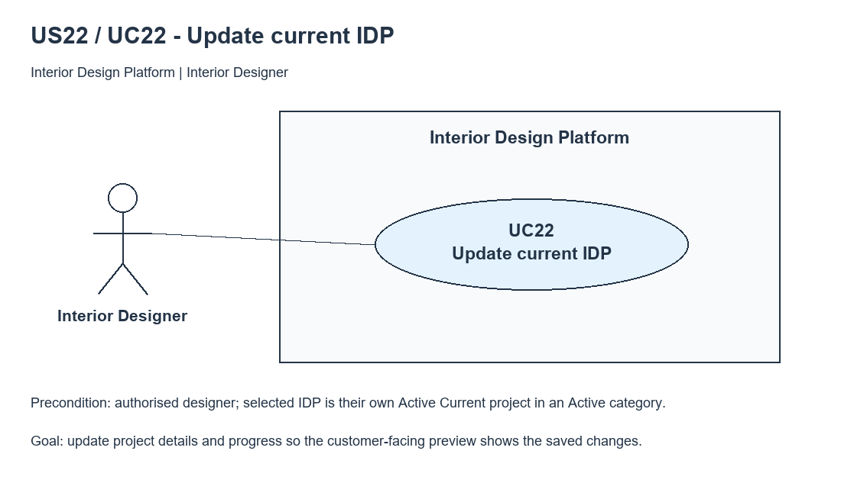
Figure 1: Use case diagram for US22 Update current IDP

3. Use case description
Use case | UC22 Update current IDP
Actor | Interior Designer
Brief description | The designer edits a current IDP so customers can see its latest details and progress.
User story | US22: As an interior designer, I want to update a current IDP so that customers can see its latest progress.
Preconditions | Signed in as an authorised Active Interior Designer. The selected project belongs to the session owner, is Active and Current, and its source category is Active.
Trigger | The designer selects Update current IDP on a US21 project preview.
Basic flow | 1. Designer selects Update current IDP.  2. Boundary checks the session/access and obtains the session designerId.  3. Controller retrieves the owner's visible Current IDP; active categories are loaded.  4. Boundary shows the prefilled form with a hidden user/project token.  5. Designer edits the details and selects Save changes.  6. Boundary rechecks access, project visibility, form token and field validation.  7. Controller rechecks access and input and requests an update of the four editable fields.  8. Entity performs the guarded update, requiring the same owner, Active Current project and Active source/destination categories.  9. Boundary consumes the form token, flashes success and redirects to the US21 preview showing the saved values.
Alternative flows | 2a / 6a. No session: redirect to designer login and stop.  2b / 6b / 7a. Invalid or revoked designer access: HTTP 403, no update.  3a / 6c / 8a. Missing, other-owner, Past, Suspended or hidden-category project: HTTP 404, no update.  5a. Cancel: return to preview without saving.  6d. Missing, forged, stale or consumed token: HTTP 403; offer Reopen update form.  6e / 7b. Invalid fields/category: show field errors, retain typed values and do not save.  8b. Destination category becomes Suspended: show its field error without saving. Another save failure shows a retry message.
Postconditions | On success the four editable fields are stored and the updated customer-facing preview is shown. Owner, type, status and creation date are unchanged. On cancellation or failure the submission changes no IDP fields.

4. Wireframes
These wireframes match the designer header/sidebar, forms, buttons and messages in the templates folder and static/style.css. They show the update action, prefilled form, field errors and saved preview.

4a - Update action on the preview
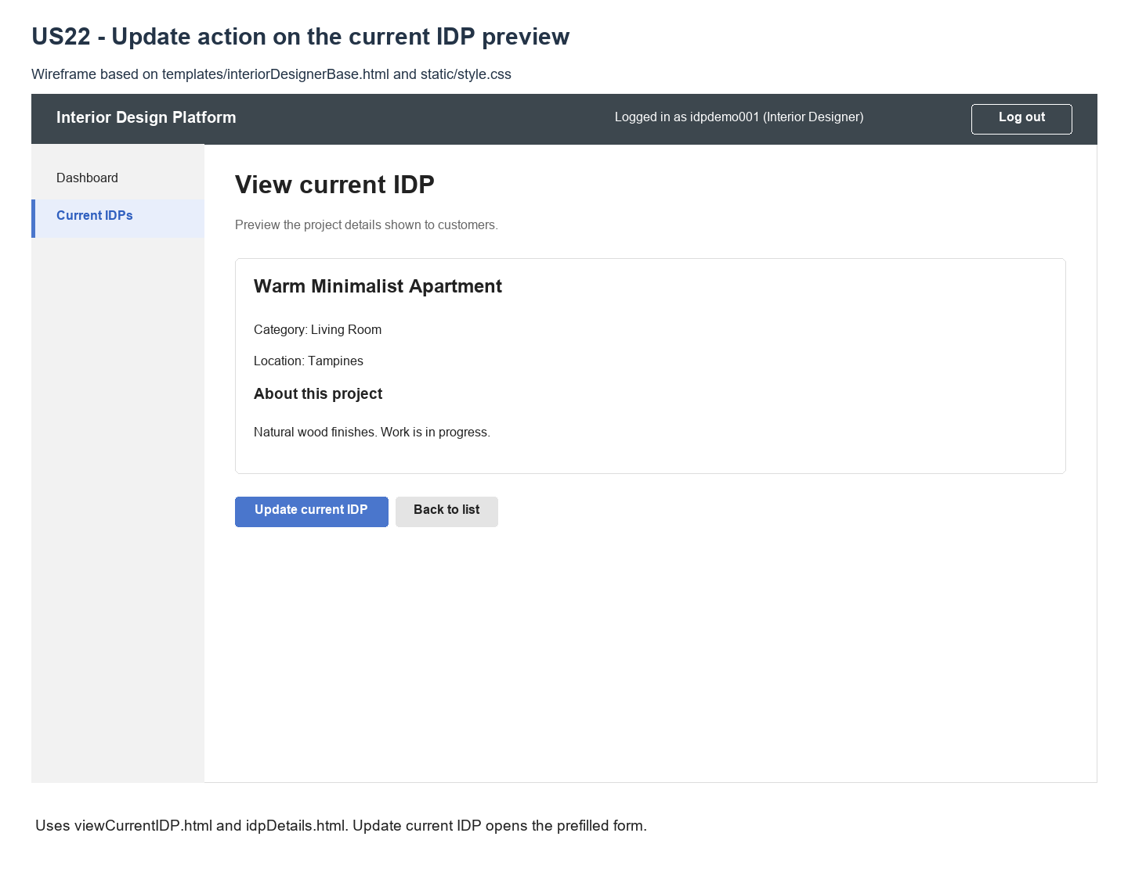
Figure 2: Wireframe 4a - Update action (US22)

4b - Prefilled update form
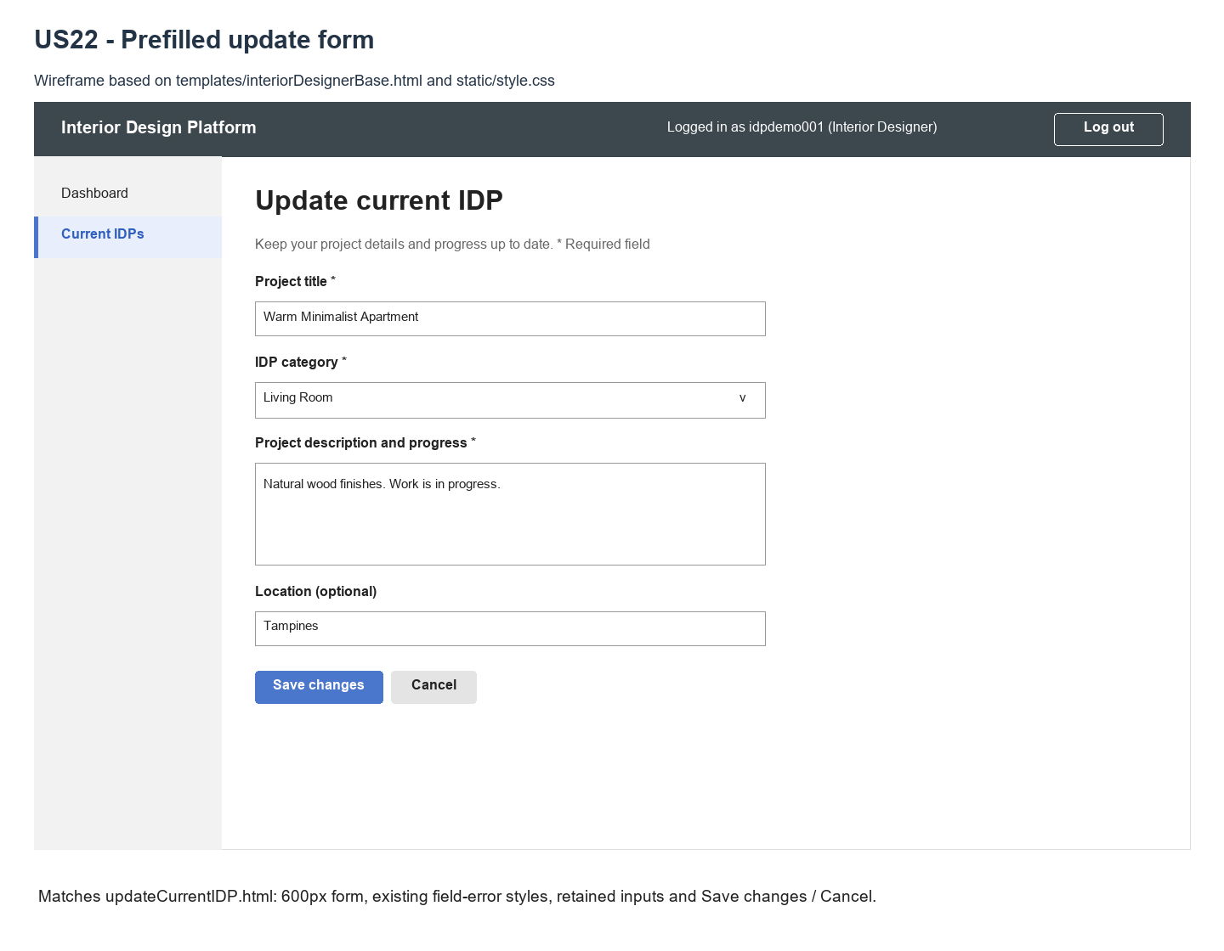
Figure 3: Wireframe 4b - Prefilled update form (US22)

4c - Validation errors
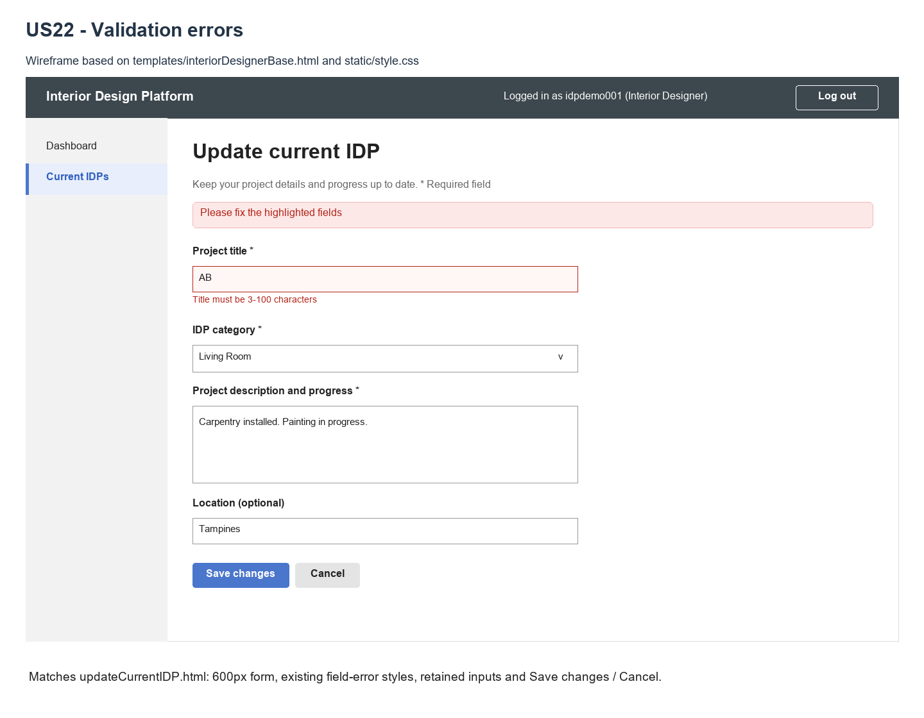
Figure 4: Wireframe 4c - Validation errors (US22)

4d - Updated preview
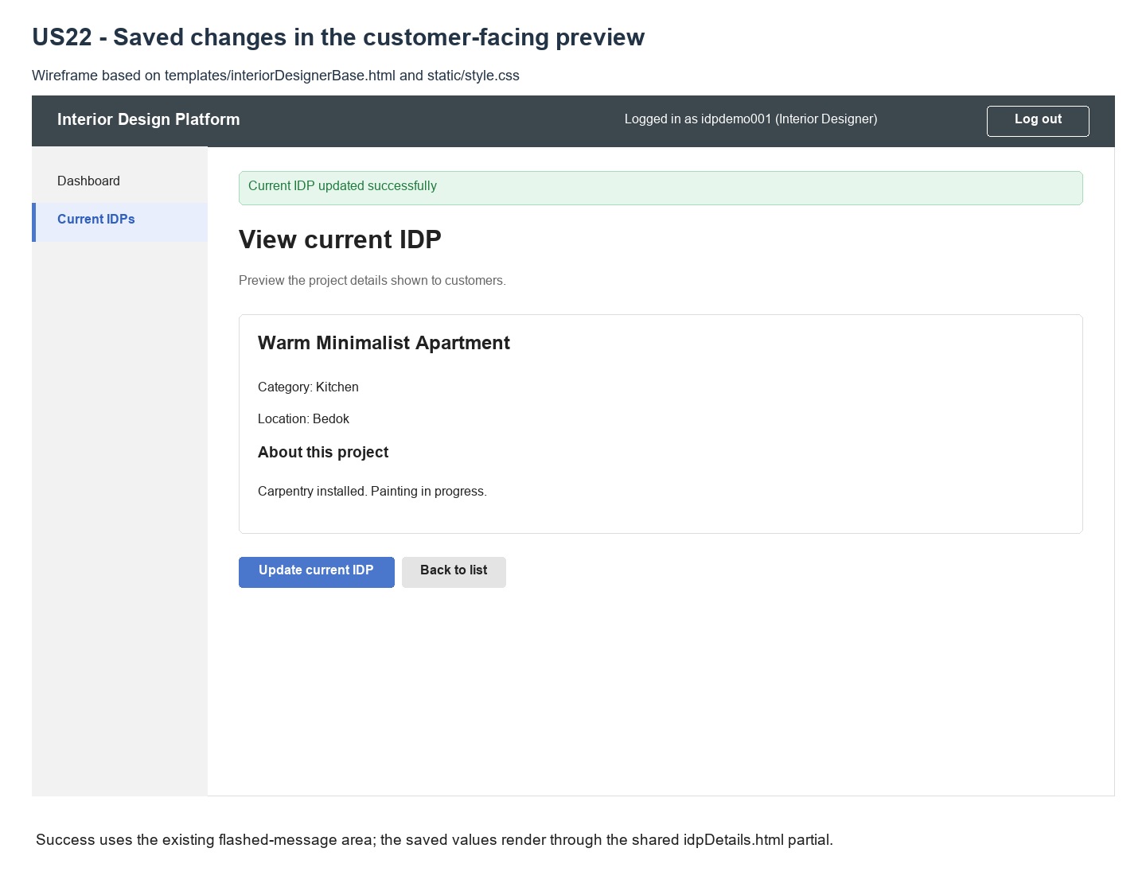
Figure 5: Wireframe 4d - Updated preview (US22)

5. B-C-E class diagram
The boundary calls its use case controller. The controller uses IDP, IDPCategory and the reused US13 access check. Only the relevant entity methods and attributes are shown.
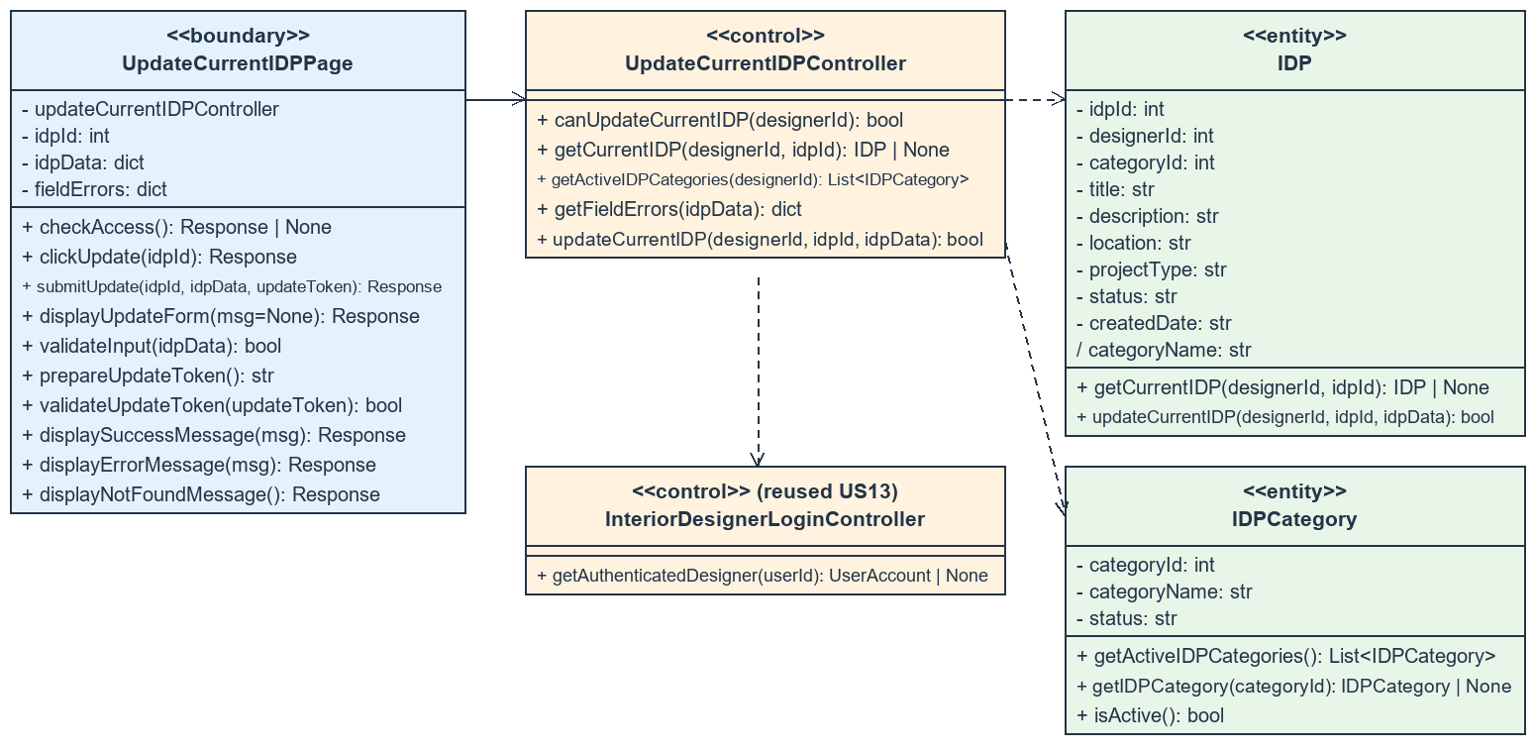
Figure 6: B-C-E class diagram for US22 Update current IDP
Layer | Class | What it does
Boundary | UpdateCurrentIDPPage | Loads/prefills the form; checks session, input and form token; keeps errors/input; redirects after saving.
Control | UpdateCurrentIDPController | Rechecks designer access, validates fields/category, loads data and delegates the update.
Entity | IDP | Retrieves the owner's visible Current IDP and conditionally updates only its four editable fields.
Entity | IDPCategory | Lists Active categories and validates the selected category.
Reused control | InteriorDesignerLoginController | Validates Active account/profile and the existing designer permissions.

6. Sequence diagram
The combined sequence covers loading the form, validating a submission, the guarded update and returning to the saved preview.
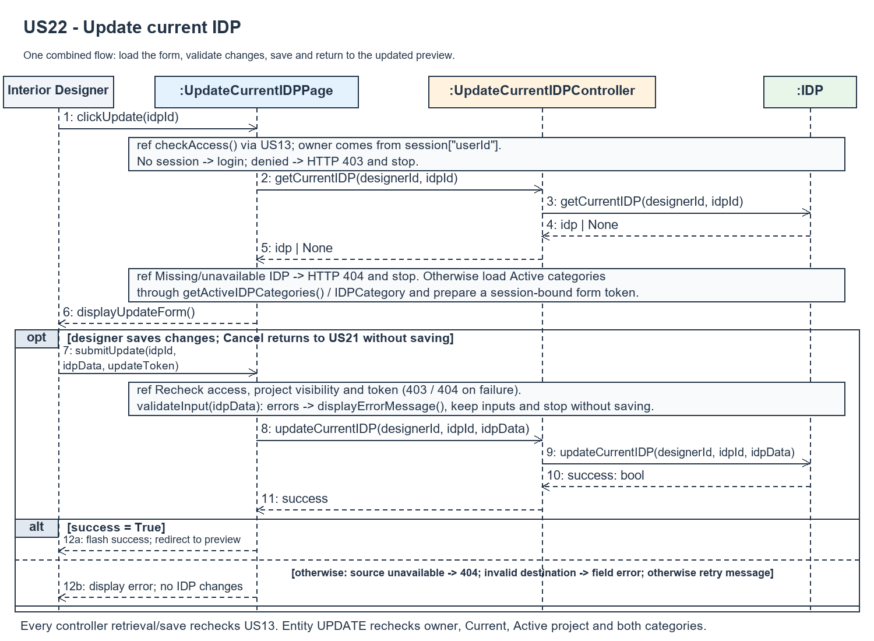
Figure 7: Sequence diagram for UC22 Update current IDP

7. Test cases
Test fixtures: designers A and B; two Active categories and one Suspended category; A's Active Current, Past, Suspended and hidden-category IDPs; and B's project. Form submissions use a token from the same user/project form.

7a. System test cases (black box)
System scenarios cover valid changes, validation boundaries, ownership, visibility, access and stale forms. Actual result and Pass / Fail remain available for manual execution.
Test ID | Scenario | Prerequisites | Test steps | Test data | Expected result | Actual result | Pass / Fail
TC22.1 | Prefilled form | A owns visible Current IDP. | Open preview; select Update. | Existing four fields. | Current values and Active categories shown.
TC22.2 | Valid save and preview | A has valid update form. | Edit fields; Save changes. | Valid title, description, location, category. | Success; redirect to saved preview.
TC22.3 | Title boundaries | Valid form/token. | Submit each title. | Empty; 2, 3, 100, 101 chars. | 3-100 accepted; others show error, no save.
TC22.4 | Description boundaries | Valid form/token. | Submit each description. | Empty; 1, 2000, 2001 chars. | 1-2000 accepted; others rejected.
TC22.5 | Location optional/limit | Valid form/token. | Save with each location. | Empty; 200, 201 chars. | Empty/200 accepted; 201 rejected.
TC22.6 | Invalid category | Valid owner form. | Submit bad category. | Missing, unknown or Suspended. | Field error; input retained; no save.
TC22.7 | Cancel | Prefilled form open. | Change text; select Cancel. | Unsaved changes. | Original preview; no data changes.
TC22.8 | Unavailable project | A signed in. | Open/submit excluded project. | Other owner, Past, Suspended, missing. | HTTP 404; no disclosure or save.
TC22.9 | Access changed | Form loaded before revocation. | Revoke account/profile/permission; Save. | Revoked designer access. | HTTP 403; no update.
TC22.10 | Visibility changed | A has loaded form. | Suspend source/destination category; Save. | Category now Suspended. | Source: 404; destination: error; no save.
TC22.11 | Invalid/stale form | A has opened form. | Omit/alter/reuse token; submit. | Missing, forged, stale or consumed token. | HTTP 403; offer reopening; no update.
TC22.12 | Only editable data changes | A has valid form. | Submit edits and forged metadata. | Posted owner/type/status/date. | Only four editable fields change.

7b. Unit test cases (for TDD)
These cases map to tests/test_us22_updateCurrentIDP.py. Controller means UpdateCurrentIDPController; Boundary means UpdateCurrentIDPPage. The 30 cases expand to 86 automated checks. Unit results record the verified pytest run; system results remain blank.
Test ID | Class and method | Input / setup | Expected output | Type | Pass / Fail
UT22.1 | Controller.getCurrentIDP() | Own visible Current IDP. | Returns existing project values. | Normal | Pass
UT22.2 | Controller.getCurrentIDP() | Other owner; Past; Suspended; hidden; missing. | None for each excluded project. | Abnormal | Pass
UT22.3 | Controller.getActiveIDPCategories() | Active/Suspended categories. | Only Active, sorted by name. | Normal | Pass
UT22.4 | Controller.getFieldErrors() | Title: 0/2/3/100/101 chars; spaces. | Only 3-100 trimmed chars valid. | Boundary | Pass
UT22.5 | Controller.getFieldErrors() | Description: 0/1/2000/2001 chars. | Only 1-2000 trimmed chars valid. | Boundary | Pass
UT22.6 | Controller.getFieldErrors() | Location: empty/200/201 chars. | Empty/200 valid; 201 error. | Boundary | Pass
UT22.7 | Controller.getFieldErrors() | Invalid/missing/Suspended category. | categoryId error. | Abnormal | Pass
UT22.8 | Controller.updateCurrentIDP() | Valid padded text; new category. | True; trimmed values/category saved. | Normal | Pass
UT22.9 | Controller.updateCurrentIDP() | Invalid title. | False; database unchanged. | Abnormal | Pass
UT22.10 | IDP.updateCurrentIDP() | A updates B's IDP. | False; database unchanged. | Abnormal | Pass
UT22.11 | IDP.updateCurrentIDP() | Past, Suspended, hidden or missing IDP. | False; no write. | Abnormal | Pass
UT22.12 | IDP.updateCurrentIDP() | Invalid/Suspended destination. | False; no write. | Abnormal | Pass
UT22.13 | Update POST | Valid edits plus forged metadata. | Only four editable fields change. | Abnormal | Pass
UT22.14 | IDP.updateCurrentIDP() | Unchanged valid values. | True; save accepted. | Normal | Pass
UT22.15 | Controller.canUpdateCurrentIDP() | Active / revoked / non-designer. | True / False as appropriate. | Normal | Pass
UT22.16 | Controller read/save/category methods | Access denied. | PermissionError; entities not queried. | Abnormal | Pass
UT22.17 | Boundary.clickUpdate() | Own existing IDP. | Prefilled form, Active options, token. | Normal | Pass
UT22.18 | Update GET/POST | No session. | Redirect to designer login. | Abnormal | Pass
UT22.19 | Update GET/POST | Signed-in User Admin. | HTTP 403; database unchanged. | Abnormal | Pass
UT22.20 | Boundary.submitUpdate() | Title AB; other fields typed. | Errors/highlight; retained input; no write. | Abnormal | Pass
UT22.21 | Boundary.submitUpdate() | Valid form and data. | Redirect; success; updated preview. | Normal | Pass
UT22.22 | Form Cancel | Open form; return to preview. | No database changes. | Normal | Pass
UT22.23 | Update POST after form load | Revoke access or change visibility. | HTTP 403/404; no submission write. | Abnormal | Pass
UT22.24 | Boundary.validateUpdateToken() | Missing, bad, unicode, stale or reused token. | HTTP 403; no update. | Abnormal | Pass
UT22.25 | Save with category race | Suspend category at entity write. | No IDP write; 404 or field error. | Abnormal | Pass
UT22.26 | Unavailable GET/POST | Other owner; Past; Suspended; hidden; missing. | HTTP 404; no data disclosed. | Abnormal | Pass
UT22.27 | Form and preview | Script text in editable fields. | Escaped HTML; no script execution. | Abnormal | Pass
UT22.28 | Preview / forged owner query | Own preview / other owner target. | Update link / HTTP 404. | Normal | Pass
UT22.29 | Boundary/controller access race | Revoke between checks. | HTTP 403 handled. | Abnormal | Pass
UT22.30 | Token scope | Token reused for other project/user. | HTTP 403; no update. | Abnormal | Pass

